DISTRICT INSTITUTE OF EDUCATION AND TRAINING
UTHAMACHOLAPURAM, SALEM -10
INTRODUCTION:
Assessment plays a major role in student learning. Assessment involves using wide variety of methods and tools to evaluate, measure and document the student learning. Assessment basically helps one to improve learning and also set direction for ongoing teaching and learning process. There are many new approaches to assessment with an emphasis on the process of learning along with the product of learning. Performance based authentic assessment is emphasized world over. In India also there is an emphasis on continuous and comprehensive evaluation of students’ learning. Development in information and communication technology has thrown open numerous possibilities for assessing student learning and providing feedback. Assessment is the process of identifying, gathering and interpreting information about students' learning.
Online educational technologies are gaining speed year by year. Students get more and more convenient with them, and paper testing is losing its importance and necessity when we talk about knowledge evaluation. Learning Management Systems and feedback tools – these digital instruments are aimed to provide students with fast and fair assessments directly after taking a test. There are lots of reasons to use educational technologies for student assessments, such as saving time, making the learning process more comprehensive and friendly, offering fast feedback, etc., for example, the Uni check Plagiarism checker Add-on for Google Docs allows students to not just avoid accidental or intentional plagiarizing, but also check their citations and references. The students can pre check their assignments before submitting them, which saves their teachers’ time for the actual grading. Also, no more stacks of papers on the table, no more lost tests, no more need of talking all assignments home. Digital assessment tools ease the lives of both teachers and learners: due to modern technologies, students can get answers to their questions without needing to interrupt each other. All their activity can be tracked by a teacher on the spot.
Technology has a vital role to play in effective and efficient assessment of learning. Modern technology offers educators a variety of new tools that can be used in the classroom. Technology can help teachers assess their students' learning as well as their performance in the classroom. Use of ICT in assessment involves the use of digital devices to assist in the construction, delivery, storage or reporting of student assessment tasks, responses, grades or feedback.
Geoffrey Crisp (2011) in the Teacher's Handbook on e-Assessment stated that the ICT based assessment can be undertaken with many devices, such as traditional desktop computers or laptops, with portable communication devices such as smart mobile phones, with digital devices such as iPads or through the use of electronic gaming devices. ICT based assessment can use a multitude of formats, including text documents or portable document formats, multimedia formats such as sound, video or images; it can involve complex simulations or games; it can also be undertaken by students in groups or individually and it can occur with large numbers of students in a synchronous or asynchronous manner. Digital assessment tools ease the lives of both teachers and learners: Finally, digital testing is fun for students, which creates a better learning environment: Working with an interested audience makes teaching easier and more desirable for learners.
Rationale for the Training:

Evaluating, reviewing and grading assignments often turn a teachers’ everyday work into an unbearable routine. Thanks to the modern online tools and the development of the mobile technology, educators can now grade students’ work quickly and easily, saving more valuable time for the actual teaching especially during this pandemic COVID-19. One of the concerns is about how much time educators have to dedicate to coming up with evaluation strategies to stimulate and guide competence development, rather than just assigning a final grade. ICT can help us follow up the learning process, but relatively few teachers are introducing new tools to manage and enhance assessment methodologies. Sometimes the problem is more related to how time consuming the process is, rather than a lack of knowledge of how to manage the tools. It is also important to add that it is difficult to move past the long tradition of assessment strategies based more on exams and tests that measure part of the competences developed and sometimes the least relevant part. Assessing the process calls for commitment from sides, teachers and students and other tools are required. Hence, the educational Technology branch is aimed to train the teachers in developing digital assessment tools.
Objectives:
- To enable the teachers to understand the significance of digital assessment tools especially during pandemic COVID-19 period.
- To develop the skill of prepare and utilize digital assessment tools in students’ assessment.
- To prepare and circulate the e-module on digital assessment tools.
- To evaluate the impact of the training and collect the feedback of the training for further improvement.
VENUE: District Institute of Education and Training, Uthamacholapuram, Salem -10

Target group:
Primary Teachers, Upper primary Teachers, Secondary Teachers and Higher Secondary Teachers of Salem District.
Duration:
Training was conducted in four spells. Two days training was conducted for each spell. Totally 8 Days were covered to complete the training program me.
No. of participants attended:
1840 Teachers
Stages of the Training:
- Development of e-module.
- Development of digital content.
- Organizing training – online mode.
- Analysis and documentation ( feedback, follow-up and impact)

Brief note about the programme:
- Stage-I:
Two days workshop
Organize a two days’ workshop on 21.12.2020 and 22.12.2020 for preparation of Digital Assessment Tools. The workshop starts with an Inauguration at 10.00 a.m. Mr S.Manikandan, Lecturer, DIET, Salem gave a key note address of this programme. Mrs R.Kavitha, Lecturer, DIET, Salem gave a welcome address. Inaugural address by Mr P.Govinda Prakash, Senior Lecturer, DIET, Salem gave an speech on “Usage of technology in classroom teaching” for the teachers. Followed by him, Dr K.Kannagi, Senior Lecturer, DIET, Salem gave a lecture on innovative methodology in teaching and learning process and Dr R.Nagalakshmi, Senior Lecturer addressed importance of technology in the current era. In this workshop 15 school teachers are participated from various blocks of Salem District. In this workshop, our DIET faculties Mr S.Manikandan, Lecturer and Mrs R.Kavitha, Lecturer and teachers are discussed the online and offline assessment tools which are easily handle by the teachers in the classroom.
List of Resource Persons
S. No | Resource Person
01 | N.Kasi Viswanathan, B.T. Asst.,  PUMS, Munniyampatti,  Konganapuram.
02 | M.Arumugam, B.T. Asst.,  PUMS, Mothaiyanur,  Sankari.
03 | P. Sekar, B.T. Asst.,  PUMS, Soorapalli,  Nangavalli.
04 | R.Senthil Kumar, B.T. Asst.,  PUMS, Nangavalli.
05 | A.SivaRamakrishnan, B.T. Asst.,  PUMS, Sarkar Kollampatti,  Salem.
06

Stage-II: Conducted a two days video shooting on 05.01.2021 and 06.01.2021 for e-module with Resource persons.
- Stage –III: Organized a training programme in four spells from 07.01.2021 to 22.01.2021 for all level (primary, middle, high and higher secondary) of school teachers at Salem District. The following eight digital assessment tools are discussed via Zoom application for two days. First day: EDUACTIV8, HOTPOTATOES, GOOGLE FORM, Learning App and Second day: NEARPOD, KAHOOT, QUIZZES and LIVE Worksheet. In each spell, we shared a pre and post-test link and also the link of these eight videos.

Time Table:

SPELL | DATE | TIME | SESSION | RESOURCE PERSON
Spell- I | 07.01.2021 | 9.45 to 10.00 | Inauguration | -
Spell- I | 07.01.2021 | 10.00-10.45 | EDUACTIV8 | Mr A.Guru,  B.t.Asst., (Maths),  Panamarthupatti.
Spell- I | 07.01.2021 | 10.45 -11.30 | HOTPOTATOES | Mr Janaki Raman,  B.T. Asst.,  Tharamangalam.
Spell- I | 07.01.2021 | 11.30-12.15 | GOOGLE FORM | Mr Thangaraja,  B.T. Asst,  Panamarthupatti.
Spell- I | 07.01.2021 | 12.15-1.00 | Learning App | Mrs Santha Lakshmi, B.T.Asst.,  Panamarthupatti.
Spell- I | 08.01.2021 | 9.45 to 10.00 | Review of the day-I programme | MrS.Manikandan, Lecturer,  DIET, Salem
Spell- I | 08.01.2021 | 10.00-10.45 | NEARPOD | Mr Elavarasan, B.T. Asst.,
Spell- I | 08.01.2021 | 10.45 -11.30 | KAHOOT | Mrs Hemalatha, B.T.Asst., (Maths)  Salem Urban.
Spell- I | 08.01.2021 | 11.30-12.15 | QUIZZES | Mr SivaRamakrishnan, B.T. Asst.,  Sarkar Kollapatty,  Salem Rural.
Spell- I | 08.01.2021 | 12.15-1.00 | LIVE Worksheet | Mr M.Arumugam, B.T.Asst.,  Sankari.
Spell - II | 11.01.2021 | 9.45 to 10.00 | Inauguration | -
Spell - II | 11.01.2021 | 10.00-10.45 | EDUACTIV8 | Mr A.Guru,  B.t.Asst., (Maths),  Panamarthupatti.
Spell - II | 11.01.2021 | 10.45 -11.30 | HOTPOTATOES | Mr Janaki Raman,  B.T. Asst.,  Tharamangalam.
Spell - II | 11.01.2021 | 11.30-12.15 | GOOGLE FORM | Mr Thangaraja,  B.T. Asst,  Panamarthupatti.
Spell - II |  | 12.15-1.00 | Learning App | Mrs Santha Lakshmi, B.T.Asst.,  Panamarthupatti.
Spell - II | 12.01.2021 | 9.45 to 10.00 | Review of the day-I programme | MrS.Manikandan, Lecturer,  DIET, Salem
Spell - II | 12.01.2021 | 10.00-10.45 | NEARPOD | Mr Elavarasan, B.T. Asst.,
Spell - II | 12.01.2021 | 10.45 -11.30 | KAHOOT | Mrs Hemalatha, B.T.Asst., (Maths)  Salem Urban.
Spell - II | 12.01.2021 | 11.30-12.15 | QUIZZES | Mr SivaRamakrishnan, B.T. Asst.,  Sarkar Kollapatty,  Salem Rural.
Spell - II | 12.01.2021 | 12.15-1.00 | LIVE Worksheet | Mr M.Arumugam, B.T.Asst.,  Sankari.
Spell - III | 18.01.2021 | 9.45 to 10.00 | Inauguration | -
Spell - III | 18.01.2021 | 10.00-10.45 | EDUACTIV8 | Mr A.Guru,  B.t.Asst., (Maths),  Panamarthupatti.
Spell - III | 18.01.2021 | 10.45 -11.30 | HOTPOTATOES | Mr Janaki Raman,  B.T. Asst.,  Tharamangalam.
Spell - III | 18.01.2021 | 11.30-12.15 | GOOGLE FORM | Mr Thangaraja,  B.T. Asst,  Panamarthupatti.
Spell - III | 18.01.2021 | 12.15-1.00 | Learning App | Mrs Santha Lakshmi, B.T.Asst.,  Panamarthupatti.
Spell - III | 19.1.2021 | 9.45 to 10.00 | Review of the day-I programme | MrS.Manikandan, Lecturer,  DIET, Salem
Spell - III | 19.1.2021 | 10.00-10.45 | NEARPOD | Mr Elavarasan, B.T. Asst.,
Spell - III | 19.1.2021 | 10.45 -11.30 | KAHOOT | Mrs Hemalatha, B.T.Asst., (Maths)  Salem Urban.
Spell - III | 19.1.2021 | 11.30-12.15 | QUIZZES | Mr SivaRamakrishnan, B.T. Asst.,  Sarkar Kollapatty,  Salem Rural.
Spell - III | 19.1.2021 | 12.15-1.00 | LIVE Worksheet | Mr M.Arumugam, B.T.Asst.,  Sankari.
Spell -IV | 21.01.2021 | 9.45 to 10.00 | Inauguration | -
Spell -IV | 21.01.2021 | 10.00-10.45 | EDUACTIV8 | Mr A.Guru,  B.t.Asst., (Maths),  Panamarthupatti.
Spell -IV | 21.01.2021 | 10.45 -11.30 | HOTPOTATOES | Mr Janaki Raman,  B.T. Asst.,  Tharamangalam.
Spell -IV | 21.01.2021 | 11.30-12.15 | GOOGLE FORM | Mr Thangaraja,  B.T. Asst,  Panamarthupatti.
Spell -IV | 21.01.2021 | 12.15-1.00 | Learning App | Mrs Santha Lakshmi, B.T.Asst.,  Panamarthupatti.
Spell -IV | 22.01.2021 | 9.45 to 10.00 | Review of the day-I programme | MrS.Manikandan, Lecturer,  DIET, Salem
Spell -IV | 22.01.2021 | 10.00-10.45 | NEARPOD | Mr Elavarasan, B.T. Asst.,
Spell -IV | 22.01.2021 | 10.45 -11.30 | KAHOOT | Mrs Hemalatha, B.T.Asst., (Maths)  Salem Urban.
Spell -IV | 22.01.2021 | 11.30-12.15 | QUIZZES | Mr SivaRamakrishnan, B.T. Asst.,  Sarkar Kollapatty,  Salem Rural.
Spell -IV | 22.01.2021 | 12.15-1.00 | LIVE Worksheet | Mr M.Arumugam, B.T.Asst.,  Sankari.

Session wise report:
In all the four spells same sessions are followed.
Day-I
The training programme starts with Inauguration at 9.45 a.m. Mr S.Manikandan, Lecturer, DIET, Salem gave a welcome speech and key note address of this programme. Inaugural speech by Mr M.Selvam,Principal, DIET, Salem he gave an enthusiastic and motivational speech for the teachers. He also insisted about the technology era, how the teacher upgrade in their teaching process with the help of technology. Followed by Principal Mrs G.Dhanammal, Senior Lecturer, DIET, Salem gave a speech on usage of this training programme. Finally, Vote of thanks was given by Mrs R.Kavitha, Lecturer, DIET,Salem.
Session- I: Eduactiv8
This session was dealt by Mr A.Guru, B.T.Asst., In this session he explain about the tool how they (teachers) can easily handle in their classroom for students assessment for all subject at primary and middle level. He explained the process of download the application in laptop or desktop, how the teacher handle the software even an offline. At the end of the session he cleared the doubts of the teacher regarding the tool.
Session- II: Hotpotatoes
This session was dealt by Mr Janakiraman, B.T. Asst., Tharamangalam. He explain, with the help of this tool how to prepare a question paper for the students in all levels and also explain the components like JQuiz, Jcross, JMix, Jcloze and J Match which was present in this tool. At the end of the session he cleared the doubts of the teacher regarding the tool.
Session – III: GOOGLE FORM
This session was dealt by Mr Thangaraja, B.T. Asst., Panmarthupatti. In this session he clearly explain the procedure of opening the tool. He detaily explain the content how to create assessment question paper, insert of images in that question paper, allotted of marks per question and also explain the evaluation part using the excel sheet in google form. He also described how to share the question paper with the help of link through e-mail or other sources. At the end of the session he cleared the doubts of the teacher regarding the tool.
Session – IV: Learning App
This session was dealt by Mrs Santha Lakshmi, B.T. Asst., Panmarthupatti. She explain the content which is present inside the tool and also the procedure of downloading of this application. At the end of the session she rectify the doubts of the teacher.
Day-II
Second day of this training programme begins with short recap of the first day training programme by Mr S.Manikandan, Lecturer, DIET,Salem.
Session – V: Near Pod
This session was dealt by Mr Elavarasan, B.T. Asst., Panmarthupatti. In this app how the teacher can create interactivr presentations that can contain Quiz’s, polls, videos and more. He explained the procedure how the students access a teacher presentation through a code in step by step. He made the session in a live interactive mode. At the end of the session he cleared the doubts of the teacher regarding the tool.
Session – VI: Kahoot
This session was handle by Mrs Hemalatha, B.T. Asst., Salem Urban. This app brings a gaming mode platform among the students and also eagerly participate in the quiz. This platform make it easy for any individual or corporation to create, share and play learning games that drive compelling engagement. She made this session in a live interactive mode and also explained the download procedure of the KAHOOT app very clearly. At the end of the session she rectify the doubts of the teacher.
Session – VII: QUIZIZZ
This is also another learning platform session was handle by Mr Siva Ramakrishnan, B.T. Asst., Salem Rural. He explained how the teacher make content immersive and engaging. He also explain how teacher can assign student homework with help of this tool. He also made the session in a live interactive mode. At the end of the session he rectify the doubts of the teacher.
Session – VIII: Live Worksheet
This session was handle by Mr M.Arumugam, B.T. Asst., Sankari. In this session he talks about the creation of account in live worksheets, how to upload the worksheet pdf and others. At the end of the session he clear the doubts of the teacher.
PHOTOS
INAUGURATION OF WORKSHOP ON PREPARATION OF DIGITAL ASSESSMENT TOOLS
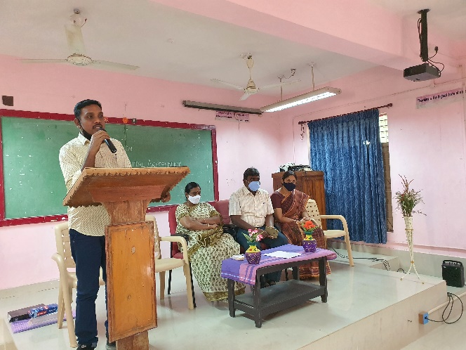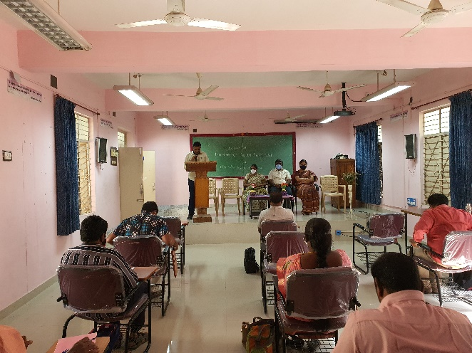

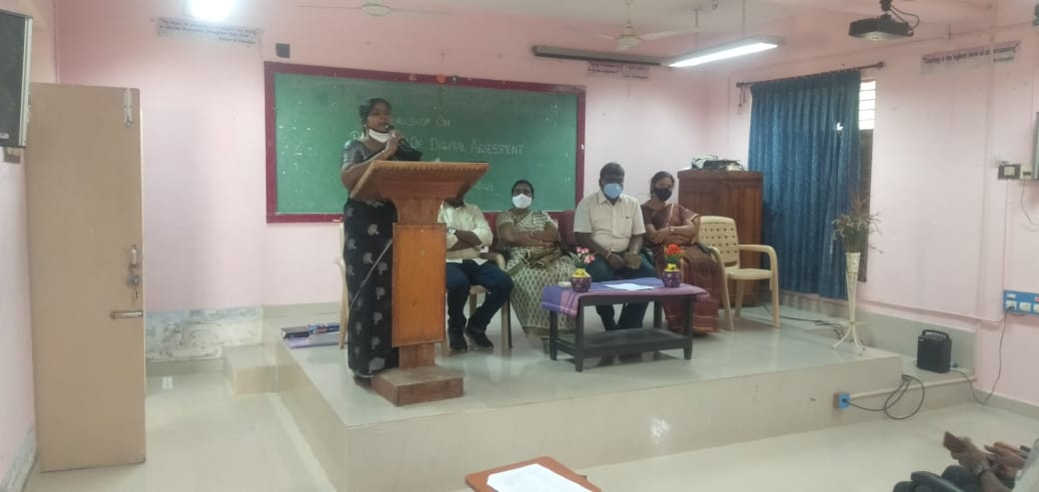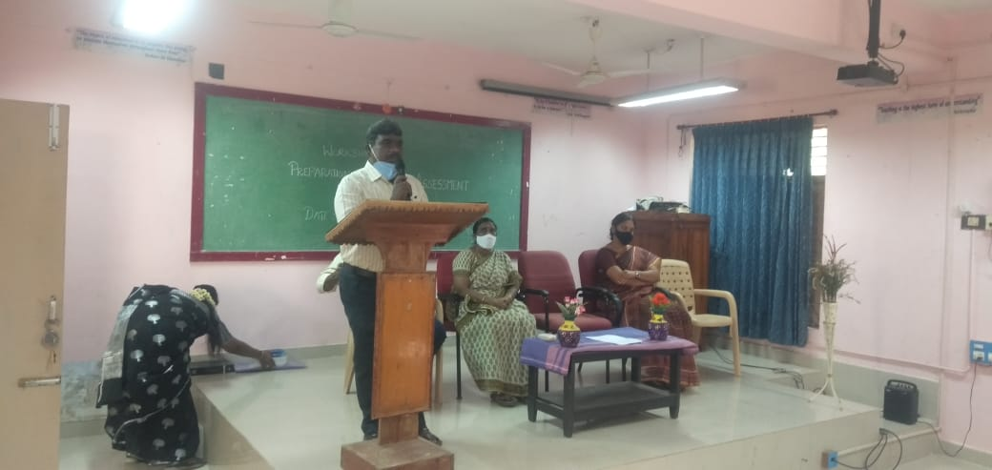
. 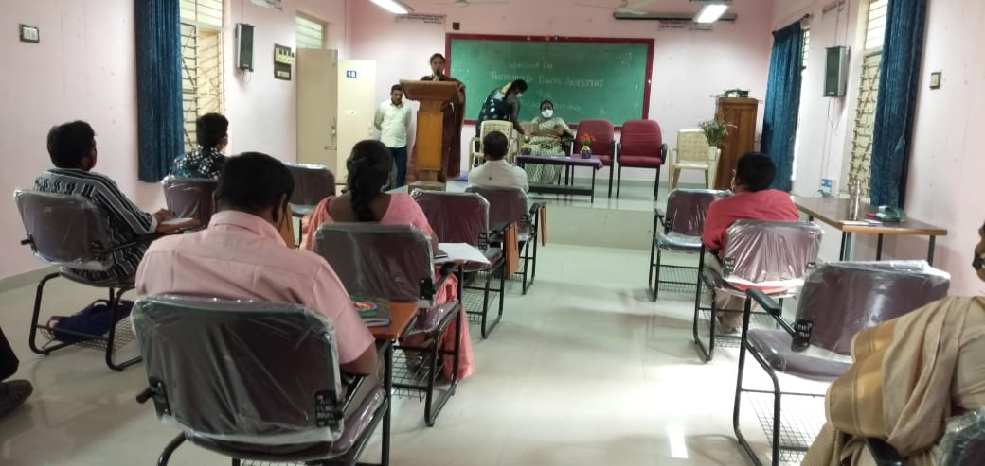 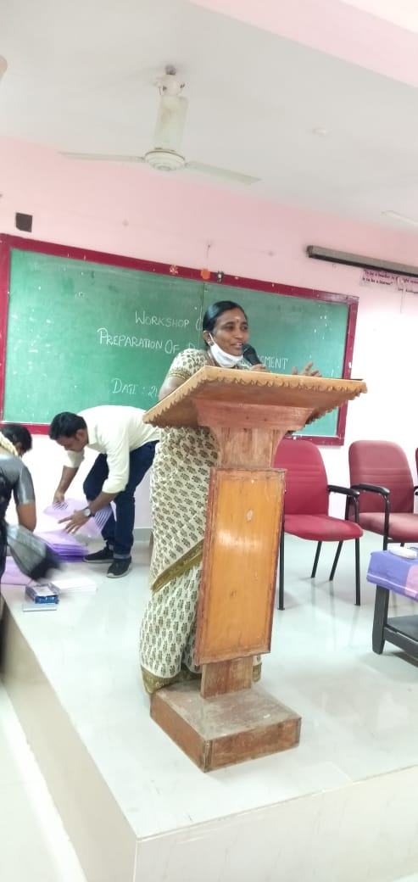
DURING WORKSHOP
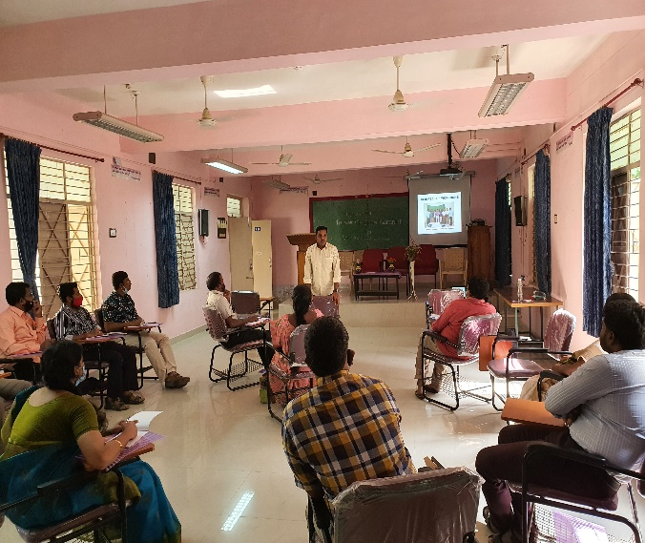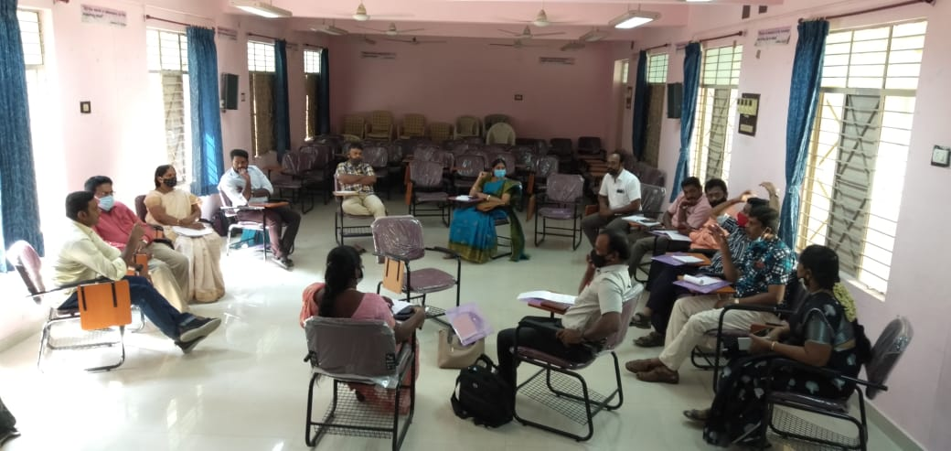
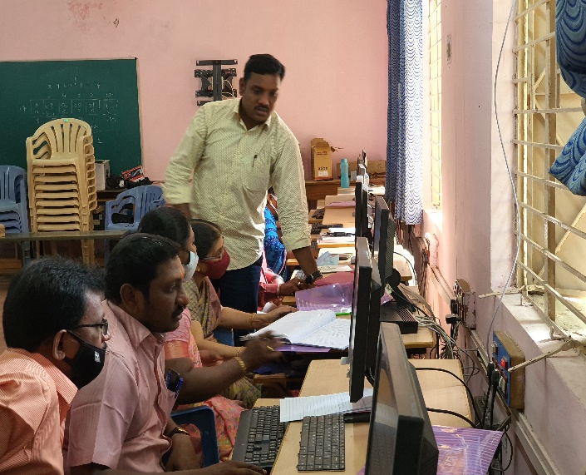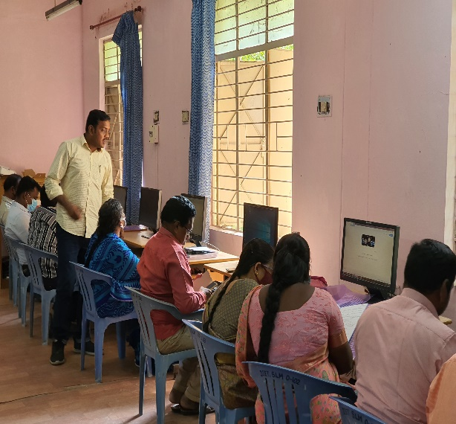
FEEDBACK:
The following feedback given by the teachers
- All the sessions in the training programme are very informative and useful in our classrooms.
- Offline tools are easy to handle in the classroom even though in the hilly area schools.
- While operating KAHOOT, QUIZZES, Live worksheets are bring an interest among students.
Teachers can use computers to construct their assessment tasks, to deliver these tasks to relevant students and to record and provide feedback and grades to these students. Computers can also be used to analyze students' responses, both to provide feedback to the student on the quality and relevance of their response, as well as to provide feedback to the teacher on whether the task can differentiate between students with different abilities. ICT based assessment can be used to test many different capabilities and skills that are developed by students. In many disciplines laboratory equipment can be manipulated remotely and students can undertake real time physical performances that are able to be recorded and used for assessment purposes.

